Resource PC Monitor

User Guide

Document Revision 1.0

Trademarks and copyrights

The descriptions and screenshots contained in this document are licensed under the Creative Commons Attribution-ShareAlike (CC-BY-SA) 3.0 license <https://creativecommons.org/licenses/by-sa/3.0/>.

**© Blue Prism Limited, 2001 – 2021**

® “Blue Prism”, the “Blue Prism” logo and Prism device are either trademarks or registered trademarks of Blue Prism Limited and its affiliates. All Rights Reserved

All trademarks are hereby acknowledged and are used to the benefit of their respective owners.  
Blue Prism is not responsible for the content of external websites referenced by this document.

Blue Prism Limited, 2 Cinnamon Park, Crab Lane, Warrington, WA2 0XP, United Kingdom  
Registered in England: Reg. No. 4260035. Tel: +44 870 879 3000. Web: www.blueprism.com

THIS DOCUMENT HAS SOLID COLOUR SECTIONS. NOT RECOMMENDED TO PRINT BY INK-JET

Contents

1. Introduction 4

2. Prerequisites 5

2.1 The File Structure 5

2.2 Dependencies 5

3. Configuration 6

4. Installation and Usage 7

4.1 BPHeartBeatMonitor Service 7

4.2 Blue Prism Notify 8

4.3 Email Settings 11

4.4 Notification Message 11

4.5 Start and Stop Service 12

4.6 Exit 12

5. Support 13

# Introduction

The Resource PC Monitor is actually 2 applications. One is a windows service that does the heavy lifting, and the other application is a configuration app that provides the data for the service to work.

Given this functionality, it will be necessary to have local admin on the computer where it is to be run. We are also providing the source code so that you can examine its functionality and also change it to fit your needs.

It will be updated over time, so any issues you discover feedback is appreciated. As with all applications of this nature, extensive testing is not possible and a best endeavours intention is provided to deal with problems and feature requests.

Both applications are written in C#. The notify application is also a WPF (Windows Presentation Foundation) application. It follows the MVVM (Model-View-ViewModel) pattern that works well for these types of applications. WPF has a steep learning curve and although is still supported by Microsoft, while it hasn’t been updated in some years. It is still an excellent foundation for desktop applications.

We recommend you study the source code before installing so that you understand fully how the application works and that there are no issues in the source code that may cause issue with your enterprise. Installation of this asset is acceptance of this condition, and Blue Prism is not responsible for any outcomes of your usage of these applications.

This application is a work in progress and additional features will be added in due course. Please send your suggestions to the [Digital Exchange Community Forum](https://community.blueprism.com/communities/community-home?communitykey=1e516cfe-4d1f-4de9-a9eb-58d15bf38c81&tab=groupdetails).

# Prerequisites

As previously discussed, the applications require local admin on a Microsoft Windows computer. Other than that there is a small configuration requirement that is required for each installation as the service, when running will execute from a system directory, access to its data folder is not obvious as we are not providing these applications with an installer. You must inform the application where the data file is on your machine.

## The File Structure

The asset is delivered as a Zip file. This file contains:

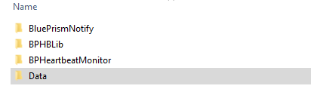

The BlueprismNotify folder is the configuration application. It provides the ability to control the service and configure the details of the assets to be monitored.

BPHLib Is a library DLL of functions used across both the configuration application and the service.

BPHeartBeatMonitor is the service that does the work. It supports an EventLog entry so its activities can be monitored.

Data contains 3 JSON files that hold the detail for the assets being monitored, the email server detail that will send the emails to the notification parties and the security information needed to login.

## Dependencies

The applications have dependencies on other libraries.

Newtonsoft.Json – Handles JSON interactions

Hardcodet.Wpf.TaskBarNotification – UI Library to assist with interactions with configuration app in system tray.

The libraries are all standard libraries available through the Nuget source.

# Configuration

The main configuration requirement is to notify the application of the location of the data folder on your computer. This data folder contains 3 JSON files, and they are used by both the configuration and the service applications. The configuration file is an XML file that can be opened in any text editor. Notepad++ is an excellent choice for working with multiple types of text files.

The file that configures this is:

If you are editing in Visual Studio, then locate the file App.Config.

The configuration file is called:

The BluePrismNotify App it is called BluePrismNotify.exe.config

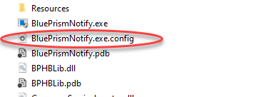

The BluePrismHeartbeatMonitor service is called BluePrismHeartbeatmonitor.exe.config.

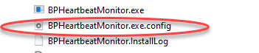

The application setting that will need your attention is the only setting in the file, it’s called DataDirectoryPath. Its value needs to be the absolute path to the data folder on your computer.



# Installation and Usage

## BPHeartBeatMonitor Service

As we are not providing an installer, it will be up to you to install the application in an appropriate location on your computer. We have a service and a desktop application. In order to install the service, we need to use a utility called *Installutil*. This application is usually found in the \Windows\Microsoft.NET\Framework\4.0.30319 folder. You may need to upgrade the version of. NET installed on your machine. This can be done online. The installation is done from an admin permissioned command prompt.

When the installation is complete, and successful you should see a result similar to the following.

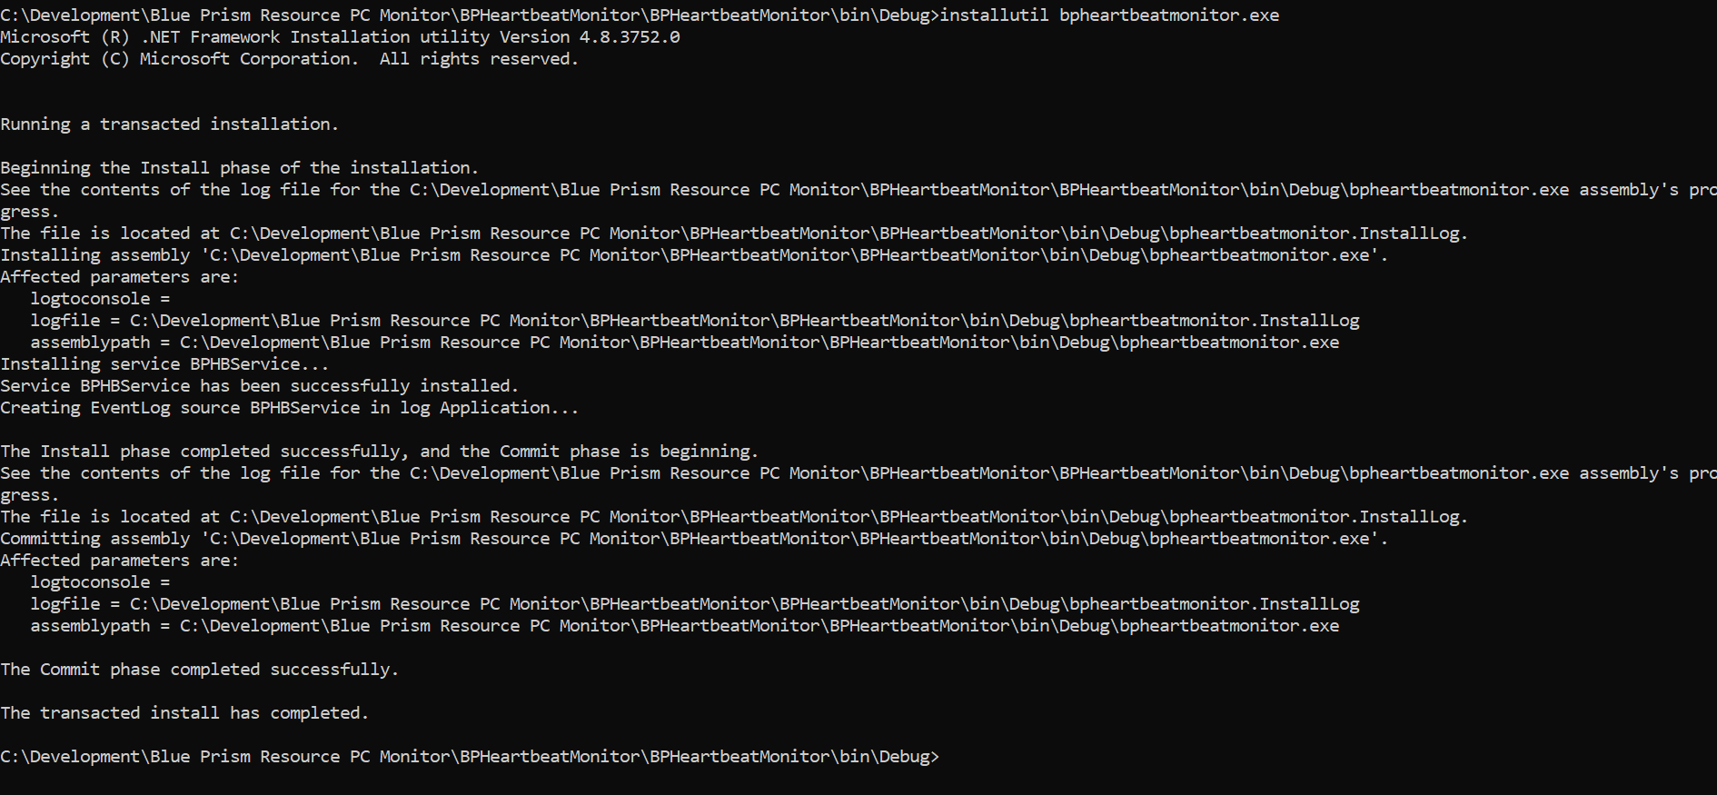

Once installed, the service will be visible on your systems services list.



You can right-click the service and from the context menu control its use. Some of this functionality is provided in the Configuration application Blue Prism Notify. As this application is a service, it has no interface. Any problems with this application on startup are usually related to the data folder not being configured correctly. The Event viewer has a log setup for this application, called, BPHLog, and should be your first place to look in the event of any problems. It is under Applications and Services Logs.

## Blue Prism Notify

When the application is running, you will find it in the system tray, by the clock on the lower right of your master screen.

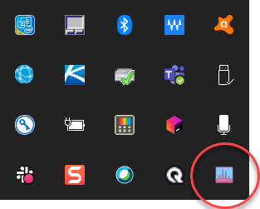

IF you mouse over the icon, a message will display. You can either double click to see the configuration screen or you can right-click and use the context menu to control the service.

Start and Stop service are self-explanatory.

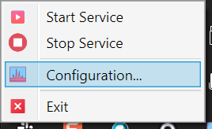

From here you can start and stop the service as you would from the Services tool. The Configuration option launches the application. Exit will actually quit the notification application and it will need to be relaunched to use again.

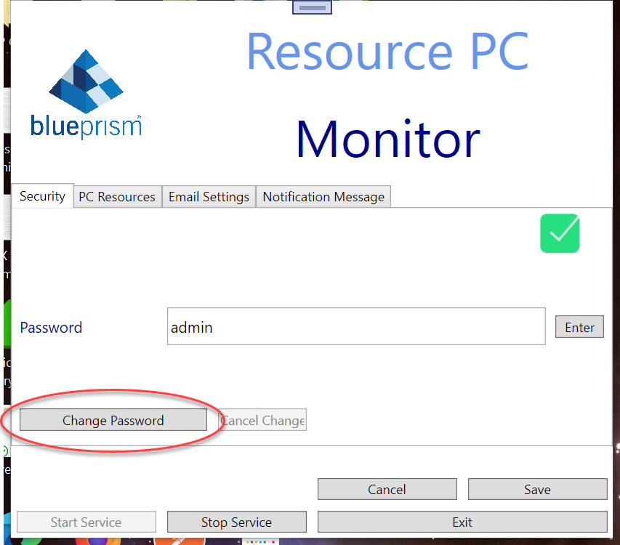

When you first launch the configuration application you will meet a security tab and this is set to admin as the default password. You must enter the password and then press tab or click the enter button. You will then see that the other tabs are now enabled.

### Security Tab

This default password can be changed using the change password button.

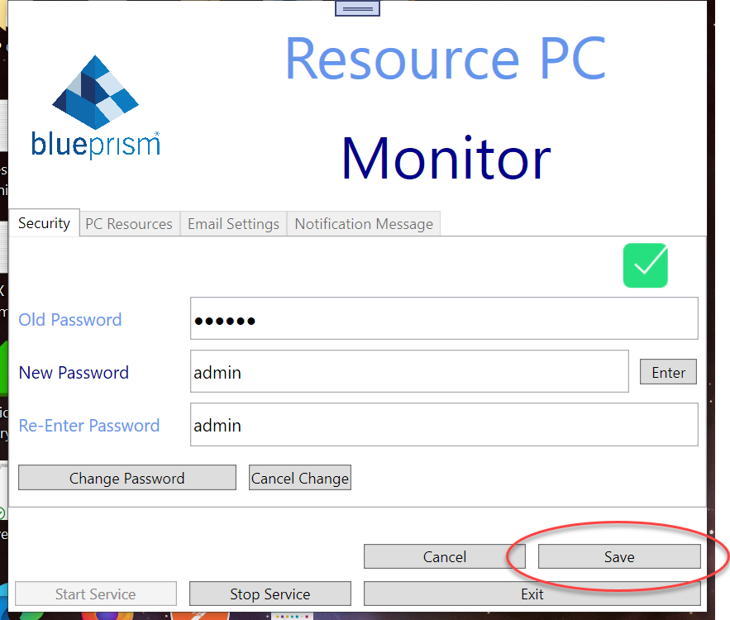

When you have made your changes, you must click save to persist them

### PC Resources

In order to add your Blue Prism assets, click the PC Resources tab.

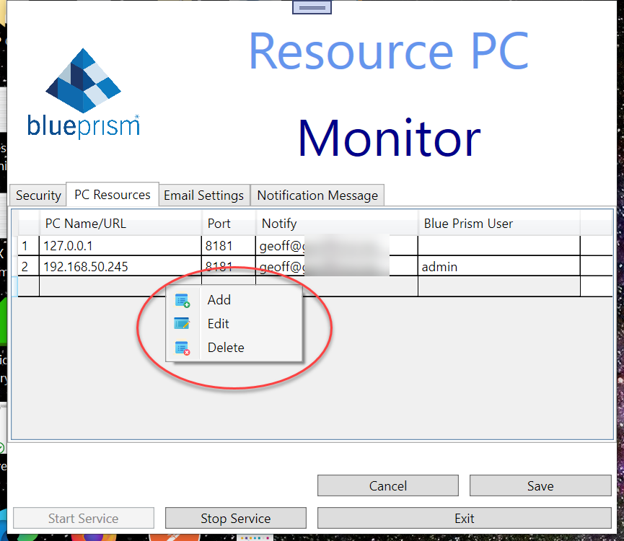

To add a PC resource, right click on the grid area shown above and click add. The screen will reveal new entry areas.

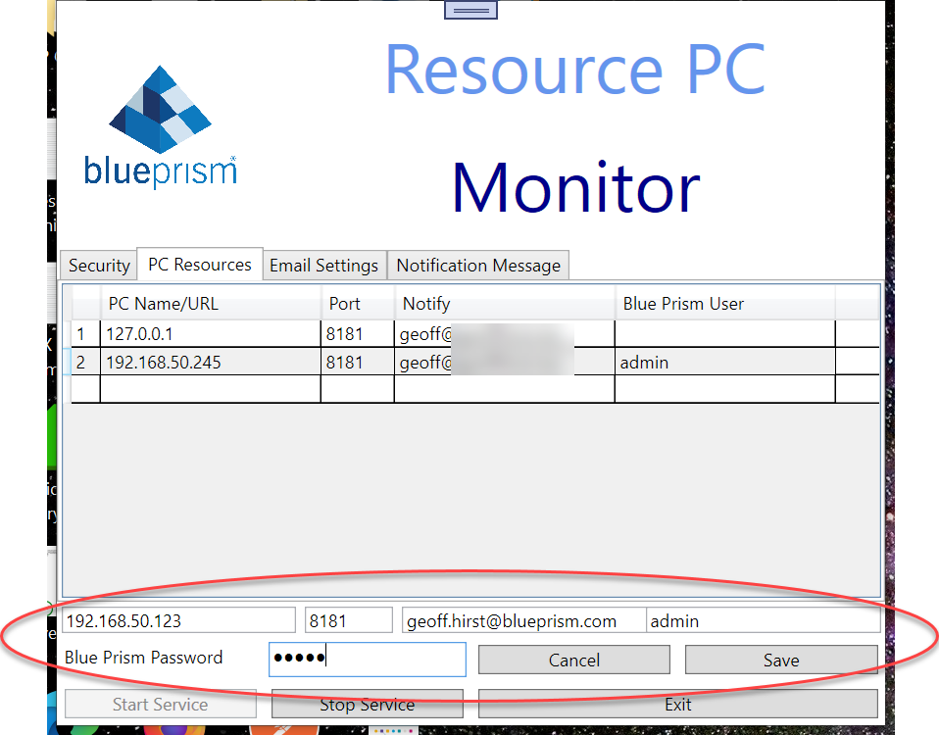

The Items shown, match the headings from the grid above. The exception being the Blue Prism password that is duly identified. Please note, the admin user is shown here for brevity, we would recommend creating a Blue Prism user specifically for this purpose.

### Edit an asset

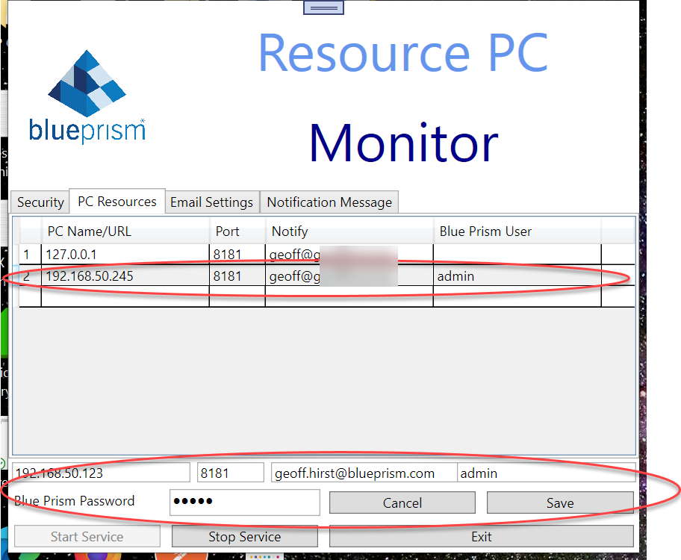

By clicking on an asset in the grid and then right-click the mouse for the context menu and choose edit, your screen should look similar to the above. Make your changes and click Save.

### Delete an Asset

Using the right-click context menu, select the asset you wish to delete and choose delete from the context menu. Save is done automatically for you.

## Email Settings

The email settings tab allows you to setup your email server details. This requires a SMTP server, a sending email address, its associated password, the port to use for the email service and finally whether you are required to use SSL for sending the email.

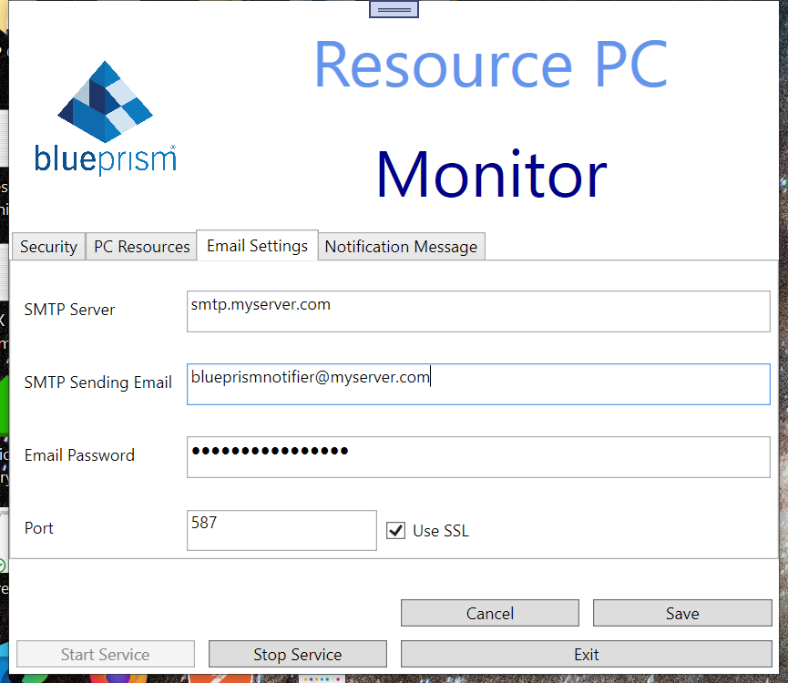

When you make your changes, click save to persist them to storage.

## Notification Message

The notification message is the text body of the email that is sent.

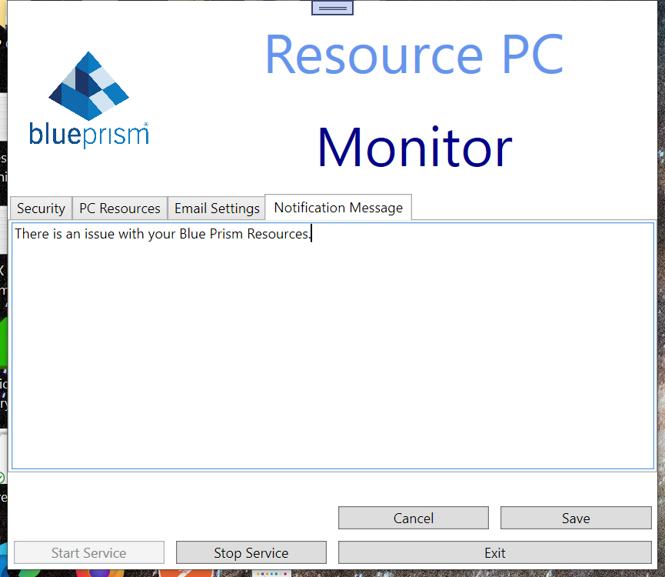

Any changes to the text should be followed by clicking the Save button.

## Start and Stop Service

|  |  |
| --- | --- |
|  |  |

The start and stop buttons perform the same action as the context menu on the system tray icon which is the same as what happens using the services control panel. In order for notifications to occur, the service must be running.

## Exit

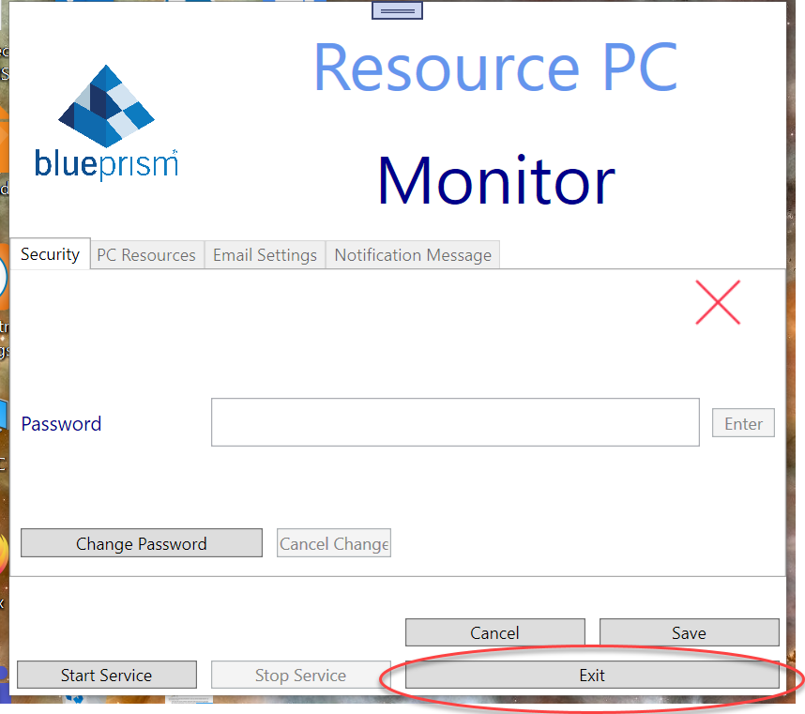

The exit button will hide the configuration form. To view it again, double click the system tray icon or right-click the context menu and choose configuration.

.

# Support

This asset is provided free-of-charge by Blue Prism. Blue Prism does not provide formal support of this asset. Please direct any questions you have, related to this asset, to the Digital Exchange Community page:

<https://community.blueprism.com/communities/community-home?CommunityKey=1e516cfe-4d1f-4de9-a9eb-58d15bf38c81>

## The Future

This application is expected to evolve and new features to be added in due course. The areas of interest are some refactoring around the main view model. This is a little on the large side and needs paring down into several view models. Mainly for the tab control. This will likely require the introduction of the Prism extensions which are a set of tools for managing composite applications. We also are looking to support SMS notification, this will however require a subscription to an SMS gateway service for this to be operational.